# Network Documentation

1. Overview:

Network Name: Abdussamad University Network

Topology: A hierarchical network topology comprising routers, switches, and VLANs.

Purpose: Providing network connectivity and management for Abdussamad University's Computer Science and Mathematics departments.

## 2. Devices

**Router: FacultyRouter1**

Hostname: FacultyRouter1

Software Version: 15.1

Management IP: Not configured (Console access only)

Purpose: Provides interVLAN routing and internet connectivity for the network.

**Interfaces**

GigabitEthernet0/0: Unassigned (Internetfacing interface)

GigabitEthernet0/0.3: VLAN 3 gateway (192.168.3.1/24)

GigabitEthernet0/0.33: VLAN 33 gateway (192.168.33.1/29)

GigabitEthernet0/1: Unassigned (Connected to switches)

GigabitEthernet0/1.7: VLAN 7 gateway (192.168.7.1/24)

GigabitEthernet0/1.77: VLAN 77 gateway (192.168.77.1/29)

**DHCP Configuration**

Provides DHCP services for VLANs 3 and 7.

**Routing**: Default route is configured for internet access.

**Switch: MATHSW1**

Hostname: MATHSW1

Software Version: 15.0

Management IP: 192.168.77.2/29 (VLAN 77)

Purpose: Connects faculty computers in the Mathematics department.

Interfaces:

FastEthernet0/1: VLAN 77 (Faculty computers)

GigabitEthernet0/1: Trunk port (Connected to FacultyRouter1)

Security:

Port security features can be implemented to restrict unauthorized access to ports.

Switch: CSCSW1

Hostname: CSCSW1

Software Version: 15.0

Management IP: 192.168.33.2/29 (VLAN 33)

Purpose: Connects faculty computers in the Computer Science department.

Interfaces:

FastEthernet0/1: VLAN 33 (Faculty computers)

GigabitEthernet0/1: Trunk port (Connected to FacultyRouter1)

Security:

Port security features can be implemented to restrict unauthorized access to ports.

3. VLANs:

VLAN 3 (compSciDHCP): 192.168.3.0/24

Purpose: Computer Science department network.

VLAN 7 (mathsDHCP): 192.168.7.0/24

Purpose: Mathematics department network.

VLAN 33 (Remote Management): 192.168.33.0/29

Purpose: Remote management interface for CSCSW1.

VLAN 77 (Management): 192.168.77.0/29

Purpose: Management interface for MATHSW1.

4. DHCP Pools:

compSciDHCP: Provides IP addresses to devices in VLAN 3.

mathsDHCP: Provides IP addresses to devices in VLAN 7.

5. Security:

Passwords: Encrypted passwords are set for console access.

Access Control: SSH access is configured for remote management.

6. Additional Notes:

Banner Message: Displays a warning message for unauthorized access.

Spanning Tree Protocol (STP): PVST mode with system ID extension is configured for loop prevention.

7. Issues/Considerations:

VLAN 900 is configured on all switches but is shutdown on all ports. Review the necessity of VLAN 900 and its associated configuration.

10. Diagram:

A visual representation of the network topology, including device connections and VLAN assignments.

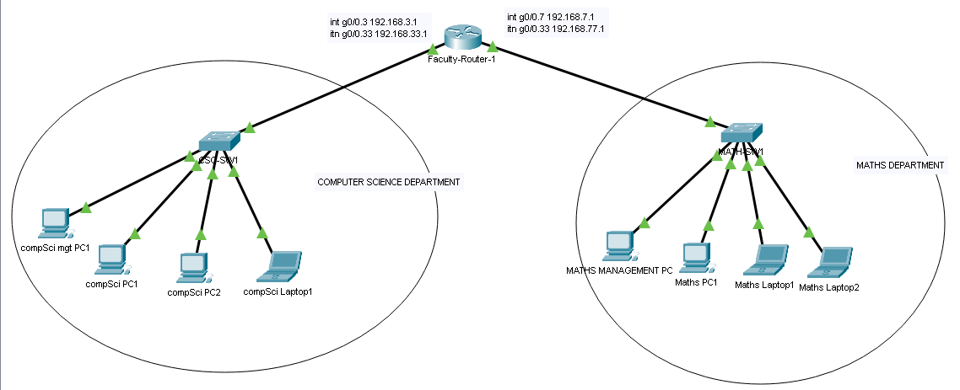

10. Support and Maintenance:

Regular network monitoring and maintenance procedures are recommended to ensure optimal performance and security.

Detailed documentation should be maintained for any future changes or updates to the network configuration.